ER Diagram

Advertise

Job

Employer

Employer

Employer {ID PK, name email, number, address}

Job {ID PK, name, jobTitle, responsibilities, requirements, address, salary, number, email}

Advertise {ID PK, empID FK, jobID FK}

Feedback {name, rate, status}

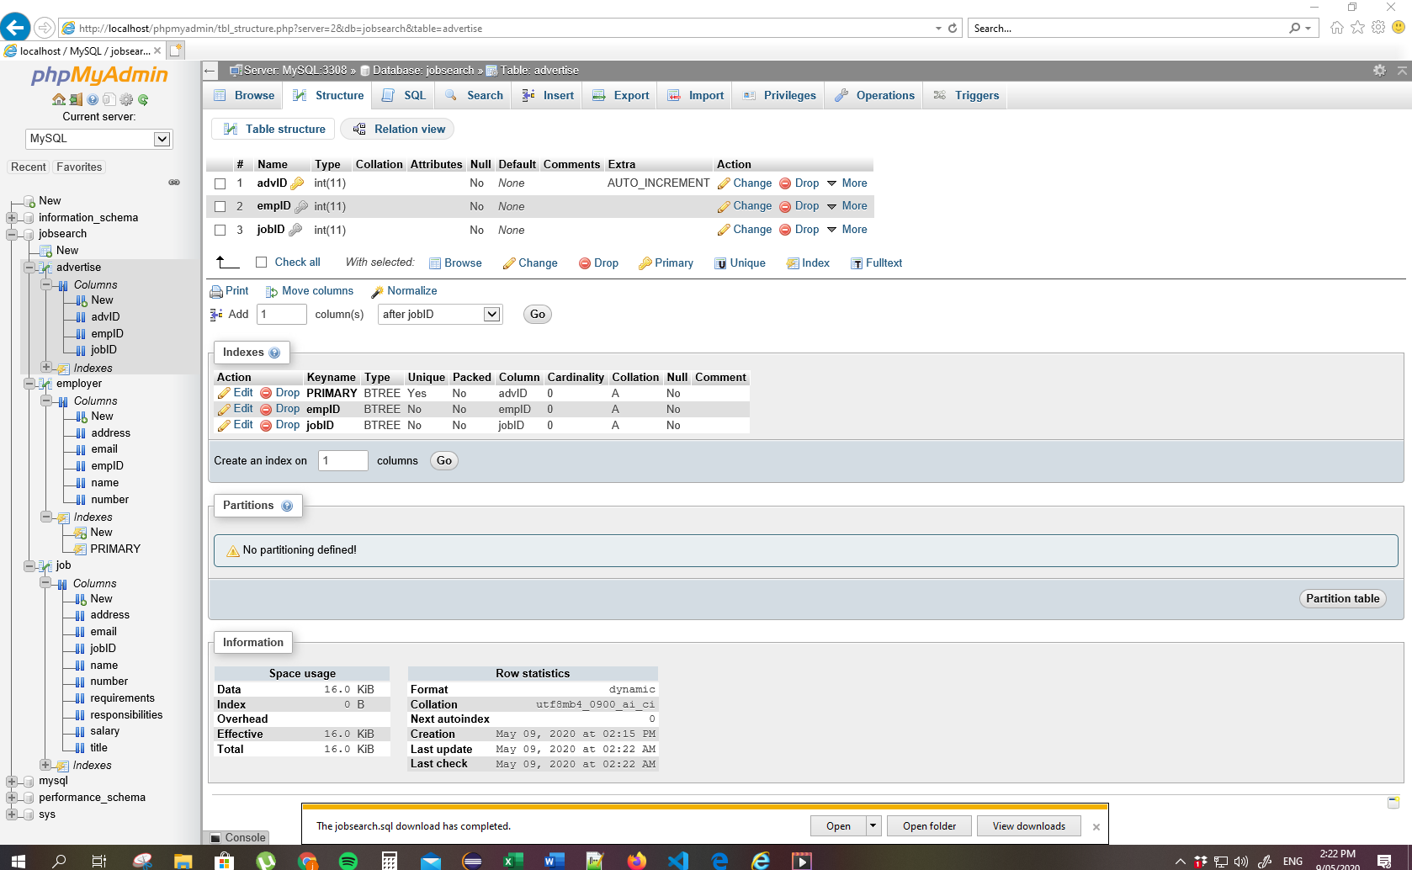

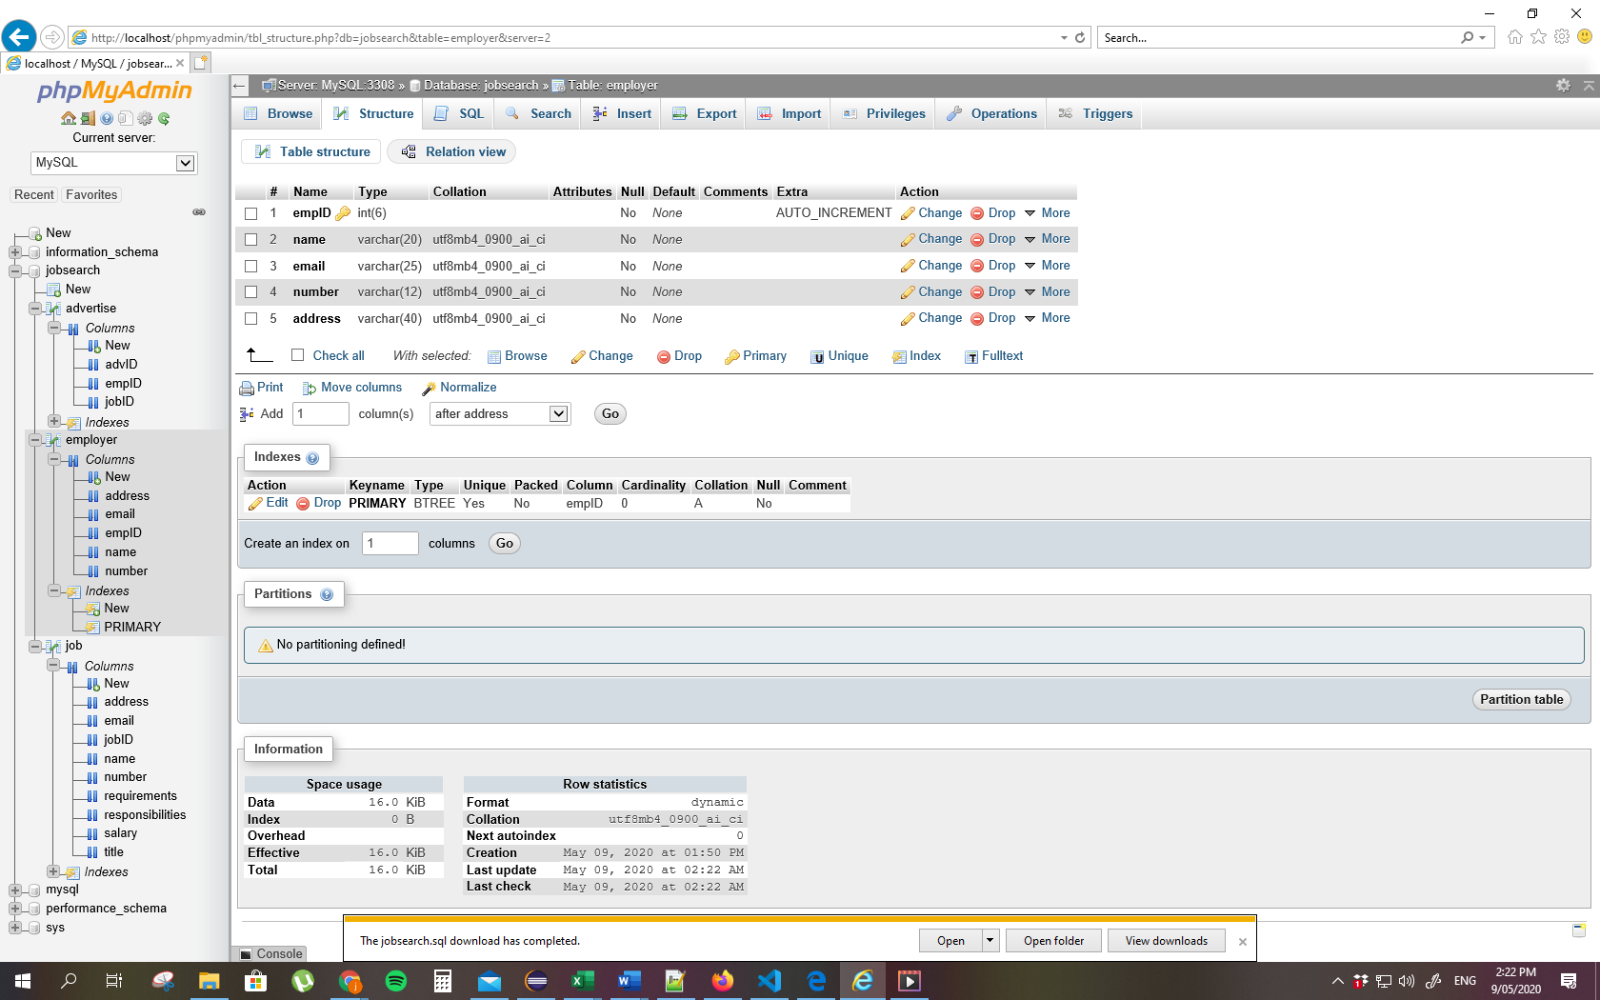

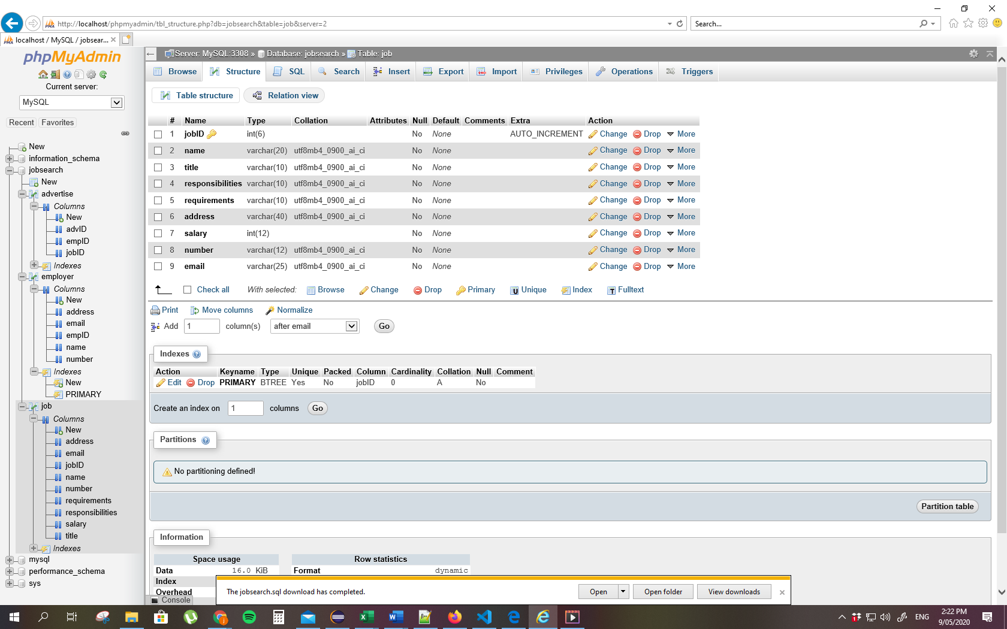

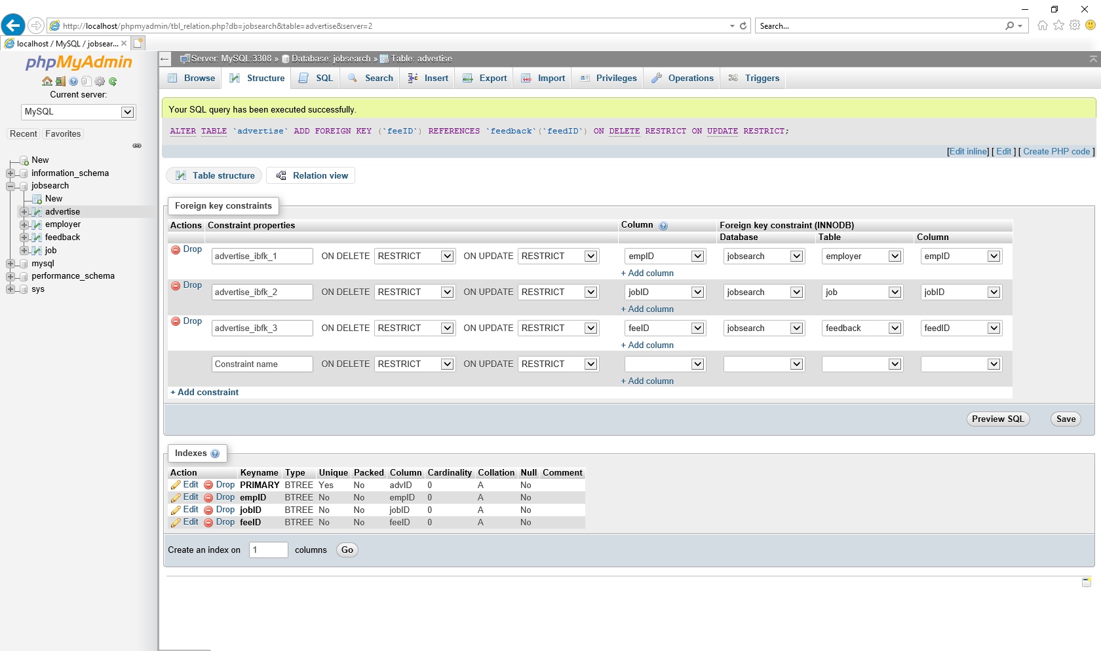 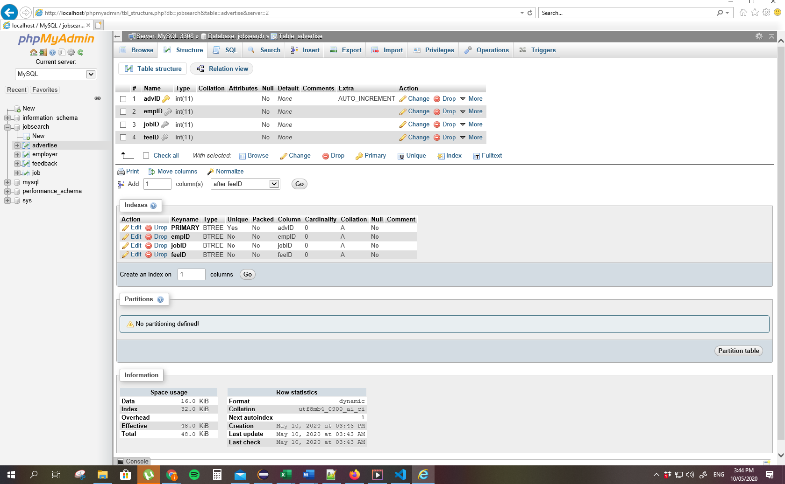

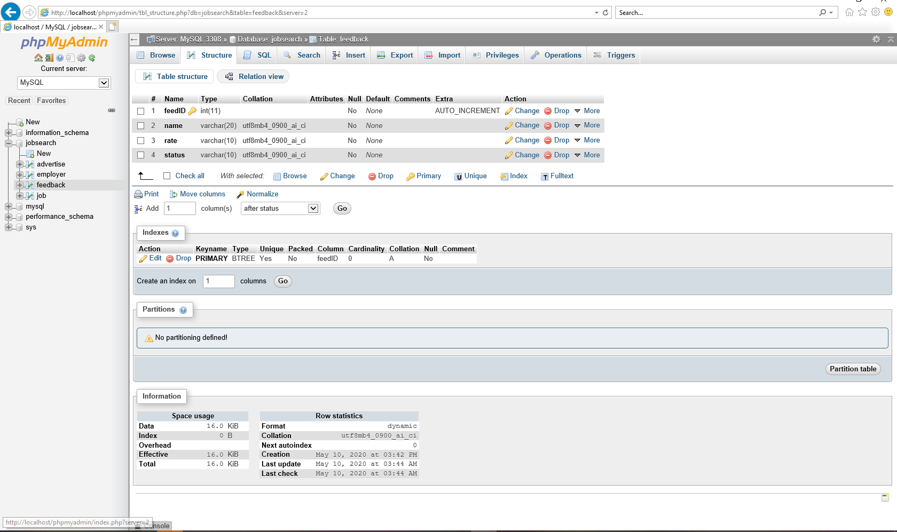

21200215 Jasmine Thomas